1 Vessel Reporting in DSM

Following Reports are to be added in DSM

Departure Report
Noon Report
Arrival Report
Port Report
Month End Report
Vessel Operations -> Bunker and Tank Condition to be updated in DSM

Following sequence is to be followed in DSM for creating reports.

Departure report to be filled first -> Noon Report -> Arrival -> Port Report

Port Report to be filled in case vessel is at anchor.

To Create Reports , Click on Vessel Operations Module -> Click on Create Reports -> Select the required report to be created.

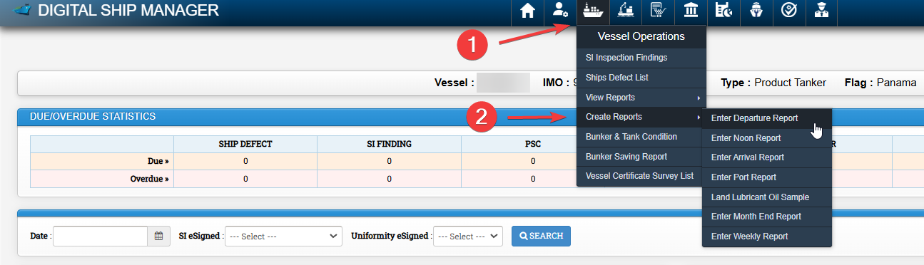

2 Bunker & Tank Condition in DSM

To add bunker tank condition ,Vessel first needs to add tanks in the system . If bunker tanks are already updated in the system , this step might not be necessary.

Go to Admin Module -> Vessel Particular

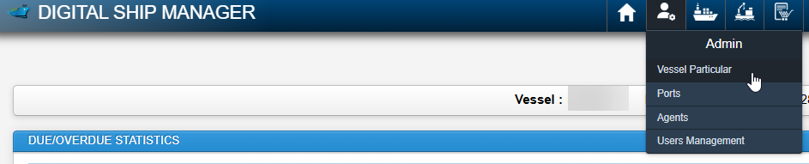

Under Vessel Bunker Tanks , Click on Edit button

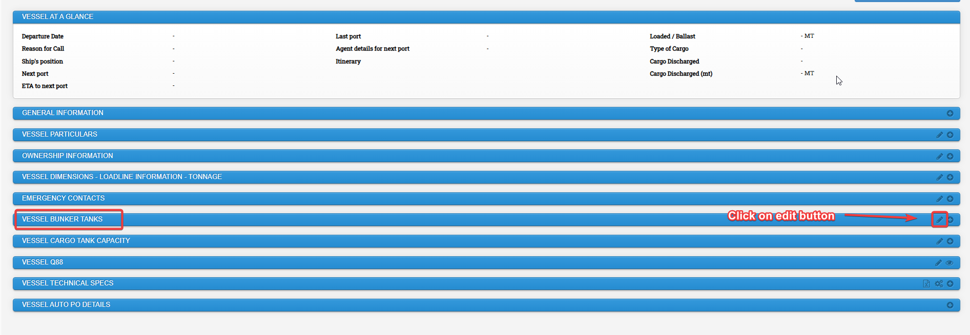

Update tanks in the system and click on save changes

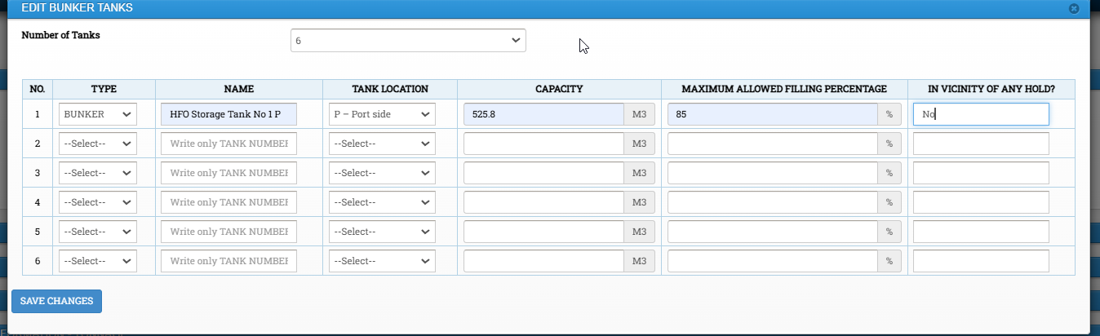

To add vessel bunker tank condition,

Click on Vessel Operations Module -> Bunker & Tank Condition

Click on Add Actual Tank Condition (ROB)

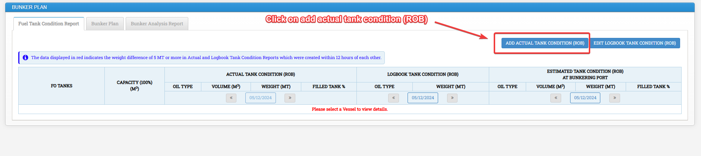

Tick on the required tanks, Fill all the required details and Click on save

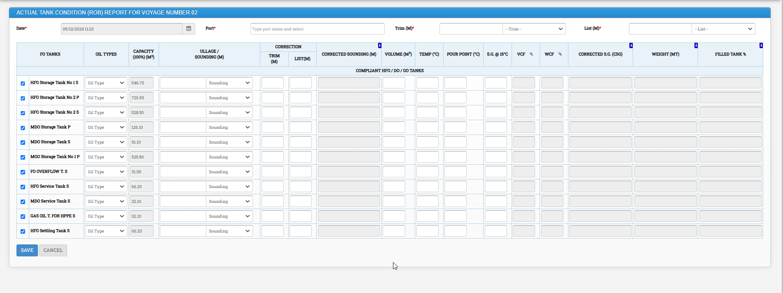

To Update the ROB , click on Edit Logbook Tank condition (ROB) and click on save button.

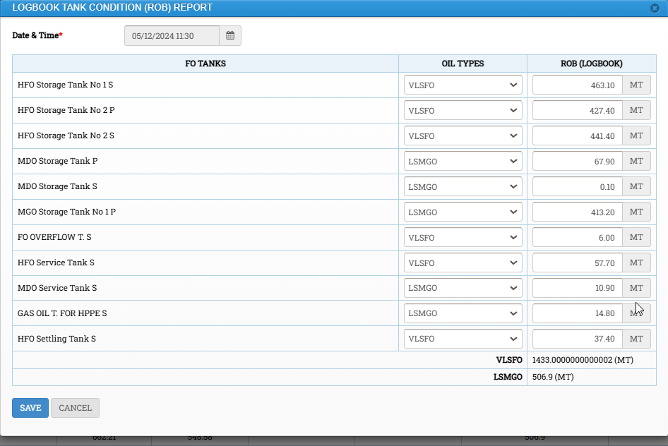

3 Bunker Plan in DSM

Click on Vessel Operations module -> Click on Bunker & Tank Condition

Click on Bunker Plan Tab -> Click on New Bunker Plan

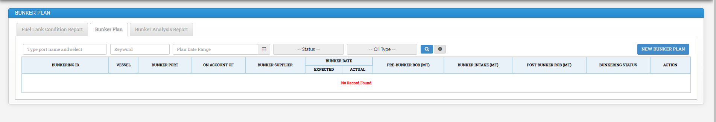

4 Video Recording on How to Create Vessel Reports

Video recordings may be accessed in DSM as following.

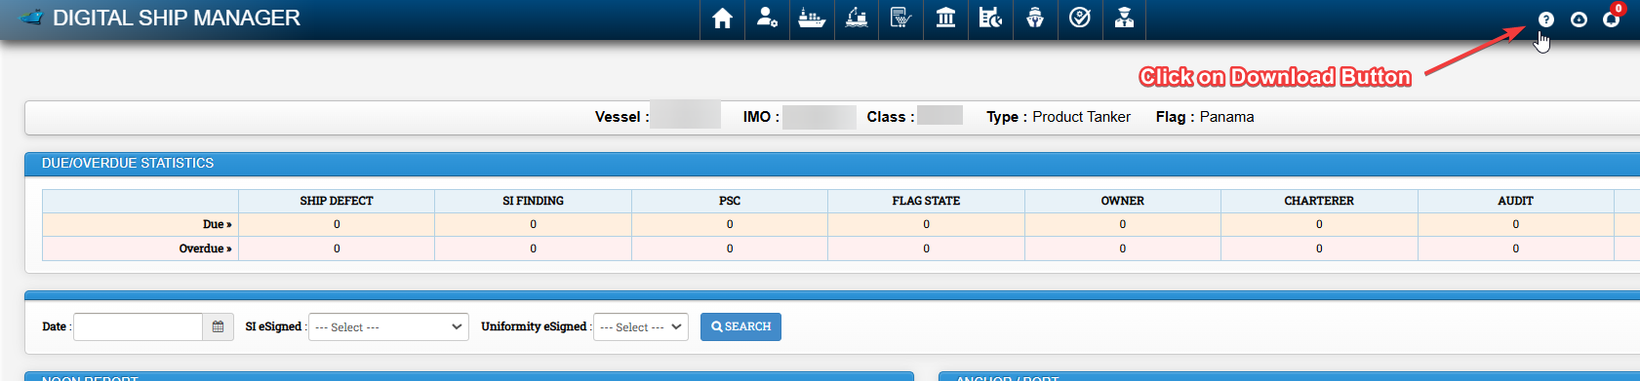

Click on Download Button

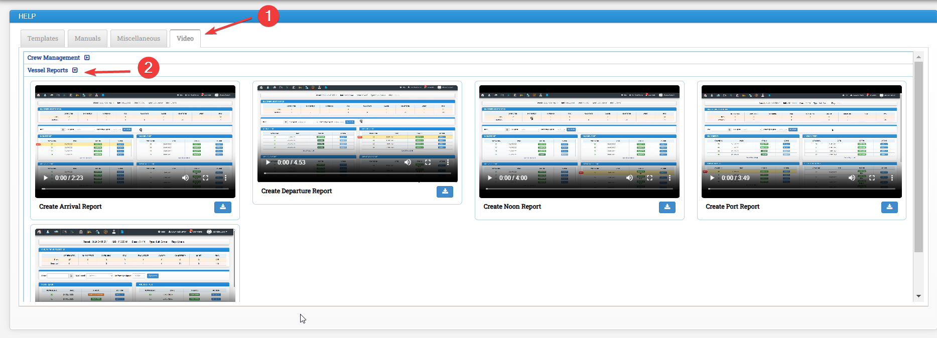

- Click on Video tab
- Click on vessel reports

